Shweta Nili
Address – S.No- 48 ,Lane No-9, Sai Nagar, Wadgaon sheri Pune- 411014
Phone - 7972952688
Email -shwetanili79@gmail.com
LinkedIn Profile - https://www.linkedin.com/in/shw eta-nili-91b2b9186

Seeking a challenging position in a professional organization that offers an opportunity for growth where my talent and experience can be harnessed to contribute to the productivity and performance to the organization, thereby enabling mutual enrichment.

Experience

Dates From – Sep 2021 to Present

Job Title - SENIOR ANALYST (MORTGAGE UNDERWRITER – CIP, doc review)

Company - Crane Consulting and Outsourcing Pvt Ltd
Key Responsibilities:

- Handling the team with the assign work & get it done by EOD.
- I have to keep informed updates in team as per email received from client.
- Review all the NBS documents & update the NBS details in application.
- Review the CIP – review the Credit report and verify with supplement mortgage document.
- Verify the received documents & update the step codes as per the job aid.
- I have to prepare the initial package which includes MOE package, Servicing Package, Collateral Package, Compliance Package.
- I have to review documents which includes – 1st Note, 1st Mortgage, loan agreement, AOM, Death Cert, Marriage Certificate, loan application, Title policy, appraisal, Tax bill, Occupancy Cert etc.
- Communicate with the clients via email for queries.
- Sending letters via UPS & correspondence to borrower for chase required documents, like Doc chase letter, Notification letter, Revoke letter, Denial letter, Initial post death letter, requirement letter etc.
- Preparing AOM as per 1st Mortgage & chain of assignment.
- Preparing excel with formulas to calculate yearly Tax & insurance amount on each loan at a one time.
- Sending daily reports to client & update MIS sheet.

Dates From – AUGUST 2019 - SEPTEMBER 2021

Job Title - PROCESS ASSOCIATE

Company - Mphasis Ltd

Key Responsibilities:

- Creating QC checklist for each and every loan using type of loan, Loan number, HLA SID.
- Responsible for verifying the Borrowers information according to the guidelines and checklist. Verifying the required documents as 1003 application, Income documents, Asset documents, Credit reports, Purchase Contracts, Run the AUS/DU, reviewing tax returns and stage the loan to underwriting for approvals or denials.
- Review the borrower documents like 4506-T, Borrower Authentication Letter, Lock in Agreement, State Disclosures, Property interest Notice, Attorney and Title, DL, Government ID proof.
- Assets documents like Bank Statements, Stocks, Bonds, Retirement funds, Checks and Gift Letters, Wire Transfer etc.
- Credit documents like Credit Report, Credit Supplements & Mortgage Statements, etc.& Check Credit Worthiness. On Credit report verify with borrower Name, SSN, DOB, Trade Lines or Creditor’s Name, Account Number, Date Open, Credit Limit, Loan Amount, Outstanding Balance, Payment History, Status and Type of Account.
- Income documents like Paystubs, Tax Returns/Tax Transcripts, VOE, WVOE, and Pension Income & Award letters etc.
- Review Entire purchase contract which includes, Buyer and Sellers name, property address, purchase price, Contingency, Brokers information, Transfer tax and other related documents.
- Found any fraud in the loan then describe all details, attach related documents and mark as witness to HLA and Underwriter for Suspect Borrower.
- Send email to our TL for query or any issue on the loan file.

Dates From – From March 2017 to August 2019

Job Title - PROCESS ASSOCIATE (Life Insurance)
Company - Tata consultancy services.
Key Responsibilities:

- Allocating work to teammates on a daily basis.
- Providing training to new recruits in the team
- Member of staff for the quotations and alteration team which helps to provide the customers quotations and altering their insurance policies as per their request.
- Mid changes are done by with team -Ex- Extend Term, Reduce Term, Reduce Sum Assured, extend sum assured as per policy holder request.
- Worked with the Change details team, add beneficiary on policy.

Education Qualification

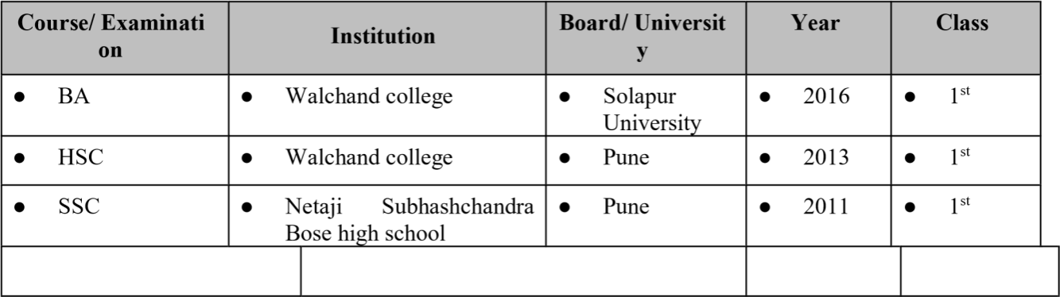

Skills
- Active Listening - Problem solving
- Hardworking, Excel, outlook
- Power BI, Advanced excel

Achievements
- Always maintained the AHT, Productivity, Quality score, Attendance -
- Received man of the match of the cricket in 2018 in TCS
- Good team player in outdoor and indoor games.
- Received appreciate certificate from the Clients.

I hereby declare that all the details furnished above are true to the best of my knowledge and belief.

Place: Pune
Date : 20 Feb 2023
(Shweta Nili)

